
Federal
Aviation
Administration

ADMIN-PE-GEN APPLY PROCESS
BUSNESS REQUIREMENTS DOCUMENT (BRD)
CONTRACT NO.

Author: GET.
Date: 7/7/2026
Version 1.0

Table of Contents
1 Introduction 1
1.1 Purpose 1
1.2 Scope of the document 1
2 Business Process Overview 1
2.1 Business Process 1
3 Use Case Description 4
3.1 DMS Home Page 4
3.2 Create application 5
3.2.1 Agreement tab: 5
3.2.2 Designee Type tab 7
3.2.3 Create Personal Profile 12
3.2.4 Background Questions – replace background question image 17
3.2.5 Designation Location 20
3.2.6 Upload Document 24
3.2.7 Summary 38
3.2.8 Signature 39
3.2.9 Message center 44
3.2.10 Application Status 45
4 Appendices 47
4.1 Appendix A: Glossary 47
4.2 Appendix B: Abbreviations, Acronyms, and Definitions 48
4.3 Appendix C: Country List: 49
4.4 Appendix D: State List 54

List of Tables
Table 1.1-1: Stakeholders vi
Table 2: Application Types 11
Table 3: Designee Questions 12
Table 4: Data Requirements – Create Personal Profile 15
Table 5: Data Requirement - Background Questions 19
Table 6: Data Requirements - Designee Locator 23
Table 7: Data Requirements – Authorizations 31
Table 8: Data Requirements - Signature 42
Table 9: Glossary 47
Table 10: Abbreviations, Acronyms, and Definitions 48

List of Figures
Figure 1: DMS Apply Process Flow Diagram 2
Figure 2: Create Application Process Flow Diagram 3
Figure 3: DMS Homepage 4
Figure 4: DMS Homepage menu 5
Figure 5: Application – Agreements 5
Figure 6: Application Agreements 6
Figure 7: Application Cancel message. 6
Figure 8: Application - Designee type 7
Figure 9: Application - Designee type questions 10
Figure 10: Designee type questions 10
Figure 11: Application - Hard stop message 11
Figure 12: Application – Create Personal Profile 13
Figure 13: Create Personal Profile - Address 14
Figure 14: Background Questions 17
Figure 15: Application – Designee Locator 21
Figure 16: Designee location - Same as personal profile 23
Figure 17: Document upload - Authorization section 25
Figure 18: Document Upload - Designee Questions 25
Figure 19: Document Upload - Designee Questions for Three Years Period 26
Figure 20: Document Upload - Attachments section 30
Figure 21: Application Signature 40
Figure 22: Eligible Application Message 41
Figure 23: Not Eligible Application Message 42
Figure 24: DMS Homepage - Submitted application 46
Figure 25: Application Versions 47

Revision History
Version Number | Date | Author | Justification
1.0 | 7/7/2026 | GET | BRD Initial Creation

Table 1.1-1: Stakeholders
Role | Name | Title | Email | Phone
Business PM | Judy Hutchens  Nicole Bonfond |  | Judy.Hutchens@faa.gov  Nicole.Bonfond@faa.gov
SME | Mitchel Salley |  | Mitchel.E.Salley@faa.gov

Introduction

Purpose
This is Business Requirements Document (BRD) that provides detail requirements for AFS Group 2 Administrative Pilot Examiner with General Authorizations (Admin PE-GEN) Apply Process. The purpose of this document is to define detailed business specifications to serve as a reference for project teams and development teams for the detailed business requirements.

Scope of the document
Designee Management System (DMS) is a system for managing all aspects of the lifecycle of designees. The fundamental high-level common processes for all designee programs contain: Application Process, Selection & Evaluation, Appointment, Oversight & Management, and Termination & Suspension. This document addresses the ‘Apply or Application Process’ where a qualified individual can apply to be appointed as Admin-PE-GEN in the DMS. The document will contain the end-to-end application process.

Business Process Overview

Business Process
This section describes the overall business process. The more detailed requirements, data requirements, and diagrams for the Admin-PE-GEN Apply Process will be part of the Use Case Descriptions sections of this document.
Apply process Requirement:
The system will:
- Allow user to create application for AFS Admin-PE-GEN designee type.
- Allow external users to add profile information.
- Collect designee related information with designee location information.
- Qualify or not qualify the application based on the user’s input.
- Allow user to edit the application and resubmit until application is selected for review.
- Allow user to cancel the application before selection begins.
- Each submission will create new application version.
- The application in selection process, cannot be edited by applicant
- Application will expire after 360 days with no update and deleted after 180 days
- Once the Application is started and saved, that application type is gone. In other words, when designee applies for the designee type Admin-PE-GEN, and comes back to apply again, the Admin-PE-GEN discipline will not be available.
    - It will be available until that application is also started and saved.
- Applications will be edited in the following conditions:
    - It’s in “submitted” status.
    - It’s in “in progress” status.
    - When the user is terminated not for cause or voluntary surrenders.
    - When the application expires.
- Applications cannot be edited in the following conditions:
    - When the designee has been selected in the selection search.
    - When the designee has been terminated for cause.

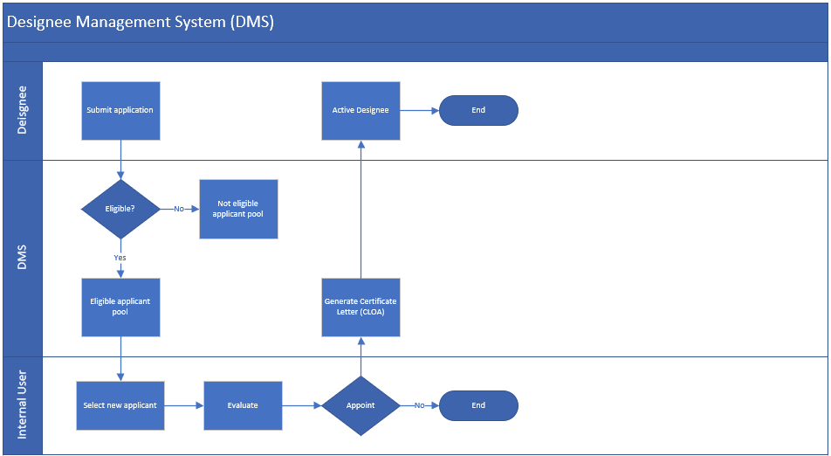
Figure 1: DMS Apply Process Flow Diagram

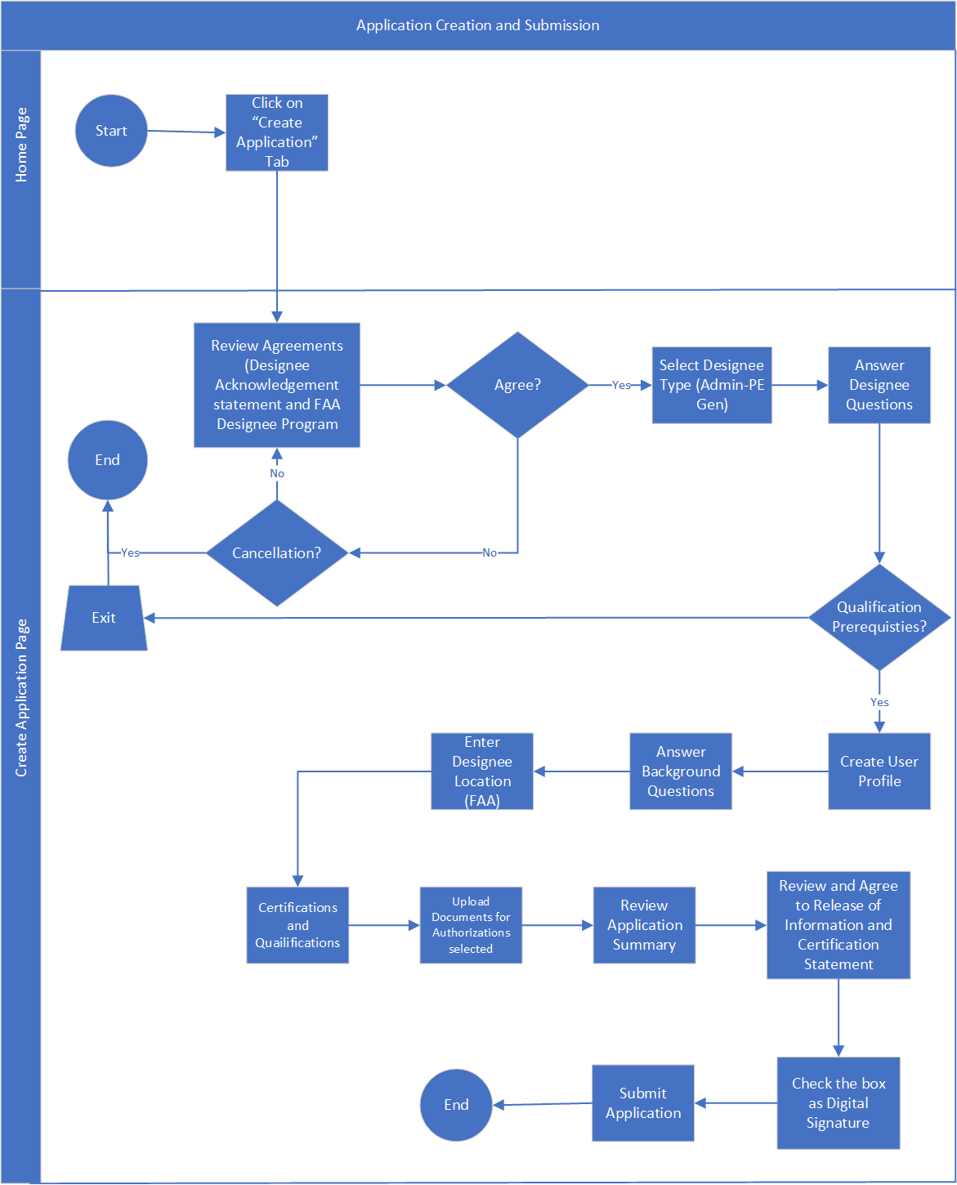
Figure 2: Create Application Process Flow Diagram

Use Case Description
This section describes requirements specifications for the Admin-PE-GEN Apply Process. External users shall register with Login.gov before applying in DMS.

DMS Home Page
DMS Homepage includes functionalities for applicants and designee. DMS homepage shall include below menu items:
- Update personal Profile
- Change designee location
- Create application
- ODA Information
- Training
- Message center
- Help
- Logout
Homepage shall be divided into sections:
- My Designations
- Action Required items
- My Applications
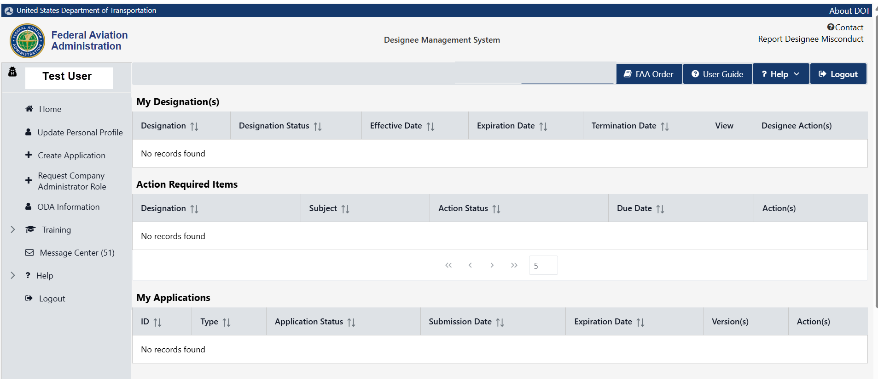
Figure 3: DMS Homepage

Create application
Registered users shall be able to start the application process when the user clicks on Create application on the menu item. Also, users shall be able to add profile information by clicking on ‘Update Personal Profile’ before starting an application. The user shall be able to start the application and return later to update/Continue and submit.

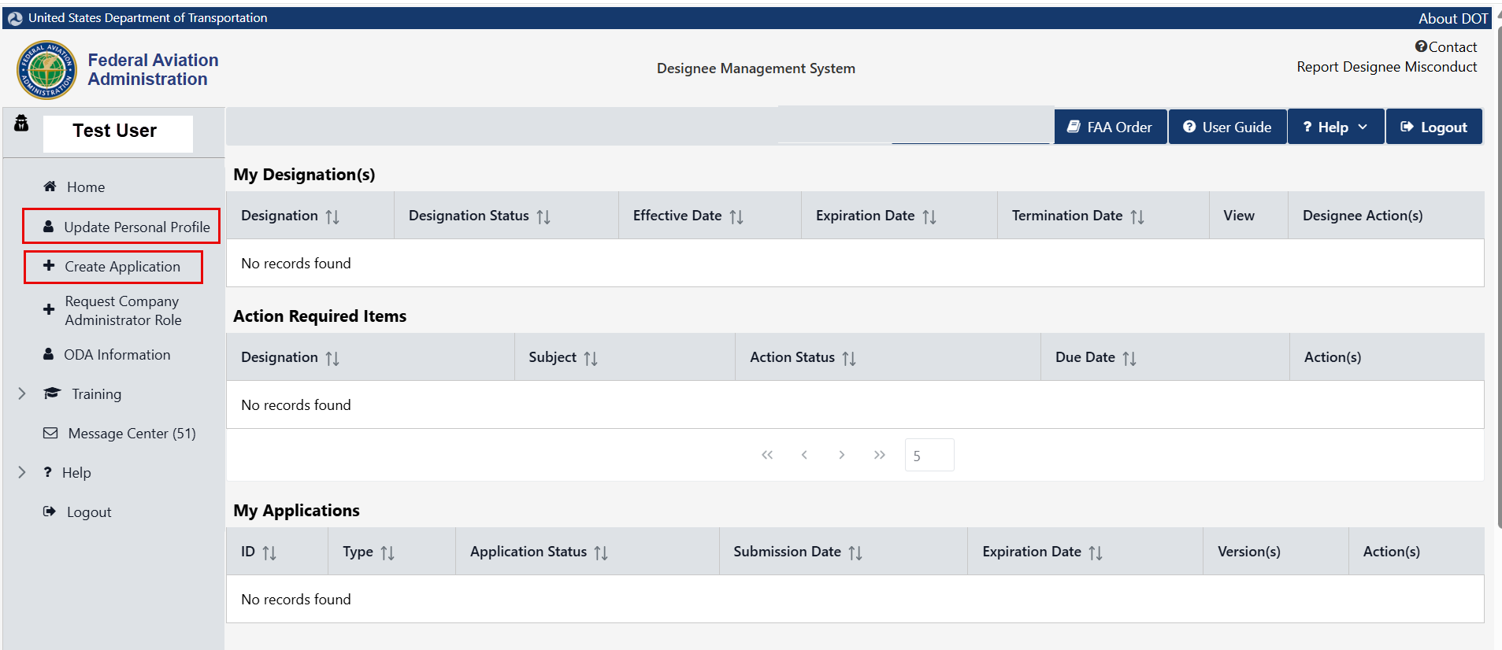
Figure 4: DMS Homepage menu
- User click on the Create application on navigation menu

Agreement tab:
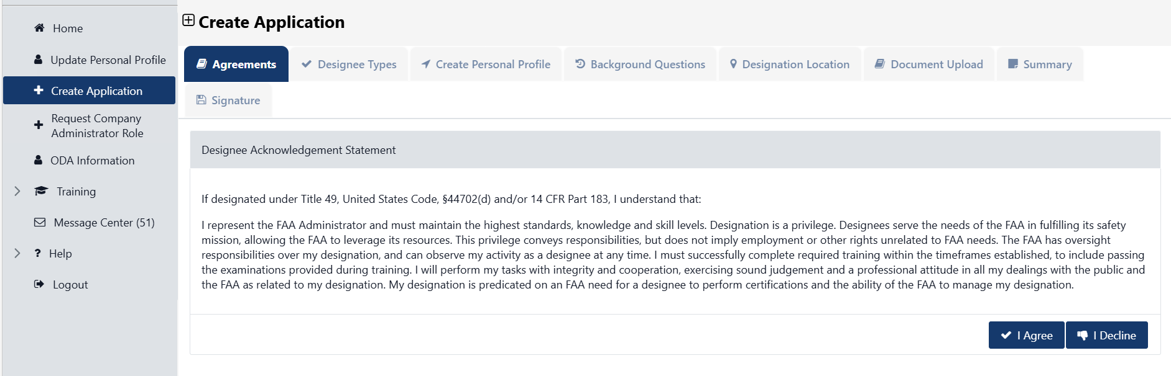
Figure 5: Application – Agreements

- The system shall display Designee Acknowledgement Statement
- User can select "I Agree" or "I Decline"
- If user selects "I Decline"
  - System returns back to Designee Home Page
- Else, user selects "I Agree"
  - System reveals the "FAA Designee Program”
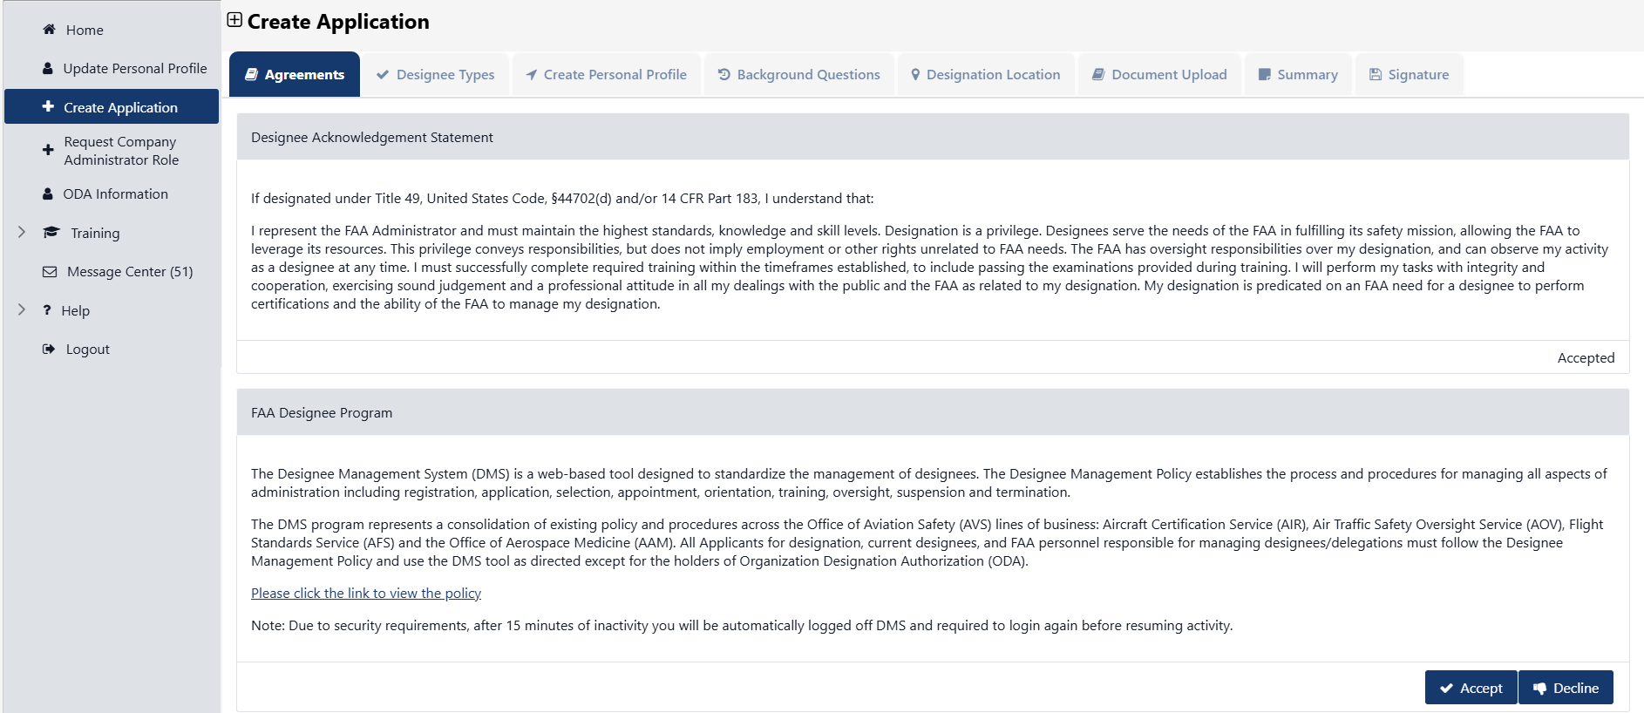
Figure 6: Application Agreements

- The FAA designee program section display ‘Accept’ and ‘Decline’ buttons
- If user selects "Decline"
  - System displays a popup Cancellation Warning “Are you sure you want to cancel this application?”
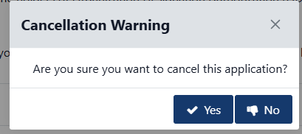
Figure 7: Application Cancel message.

  - User click on “Yes” button
    - System returns back to Home screen
  - User selects “No”
    - Applicant remains on the “Agreements” tab
- If user selects “Accept”
- System saves the data and takes the user to the “Designee Types” page.

Designee Type tab
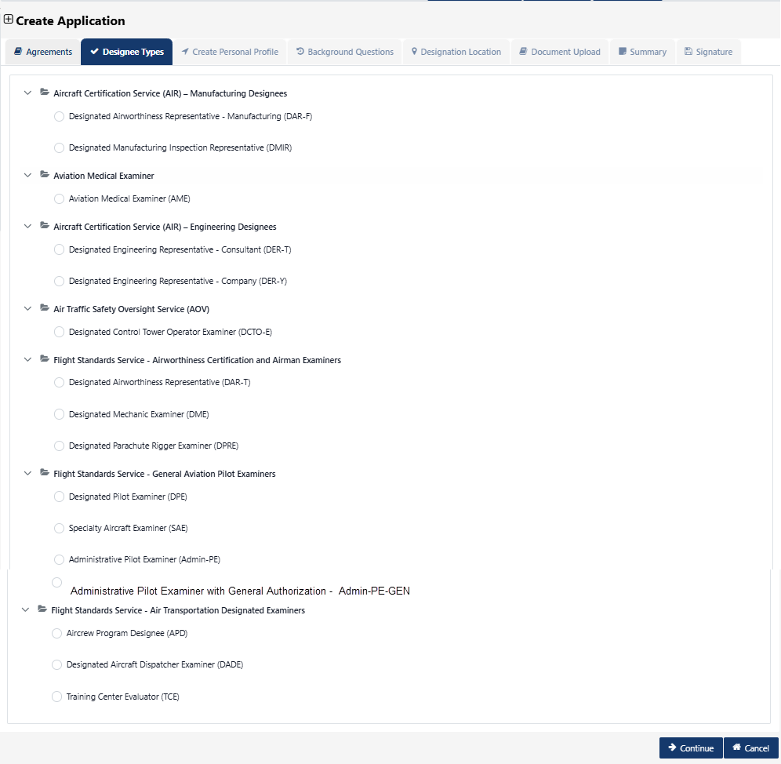
Figure 8: Application - Designee type
The system shall display the "Designee Types" page with list of application types. Each application type is listed under the organization the application belongs to.
Organization: Aircraft Certification Services (AIR):
- Designated Manufacturing Inspection Representative (DMIR)
- Designated Airworthiness Representative - Manufacturing (DAR-F)
Organization: Aviation Medical Examiner (Expand and Collapse tab)
- Aviation Medical Examiner (AME)
Organization: Aircraft Certification Services (AIR) – Engineering Designee
- Designated Engineer Representative Company (DER-Y)
- Designated Engineer Representative – Consultant (DER-T
Organization: Air Traffic Safety Oversight Service (AOV)
- Designated Control Tower Operator Examiner (DCTO-E)
Organization: Flight Standards Service - Airworthiness Certification and Airman Examiners. (Expand and Collapse tab)
- Designated Airworthiness Representative (DAR-T)
- Designated Mechanic Examiner (DME)
- Designated Parachute Rigger Examiner (DPRE)
Organization: Flight Standards Service – General Aviation Pilot Examiners (Expand and Collapse tab)
- Designated Pilot Examiner (DPE)
- Specialty Aircraft Examiner (SAE)
- Administrative Pilot Examiner (Admin-PE)
- Administrative Pilot Examiner with General Authorizations –(Admin-PE-GEN)
Organization: Flight Standards Service – Air Transportation Designated Examiners ((Expand and Collapse tab)
- Aircrew Program Designee (APD)
- Designated Aircraft Dispatcher Examiner (DADE)
- Training Center Evaluator (TCE)
At least one designee type shall be selected if no designee type is selected then the system shall display error message.
- Designee Type is Required
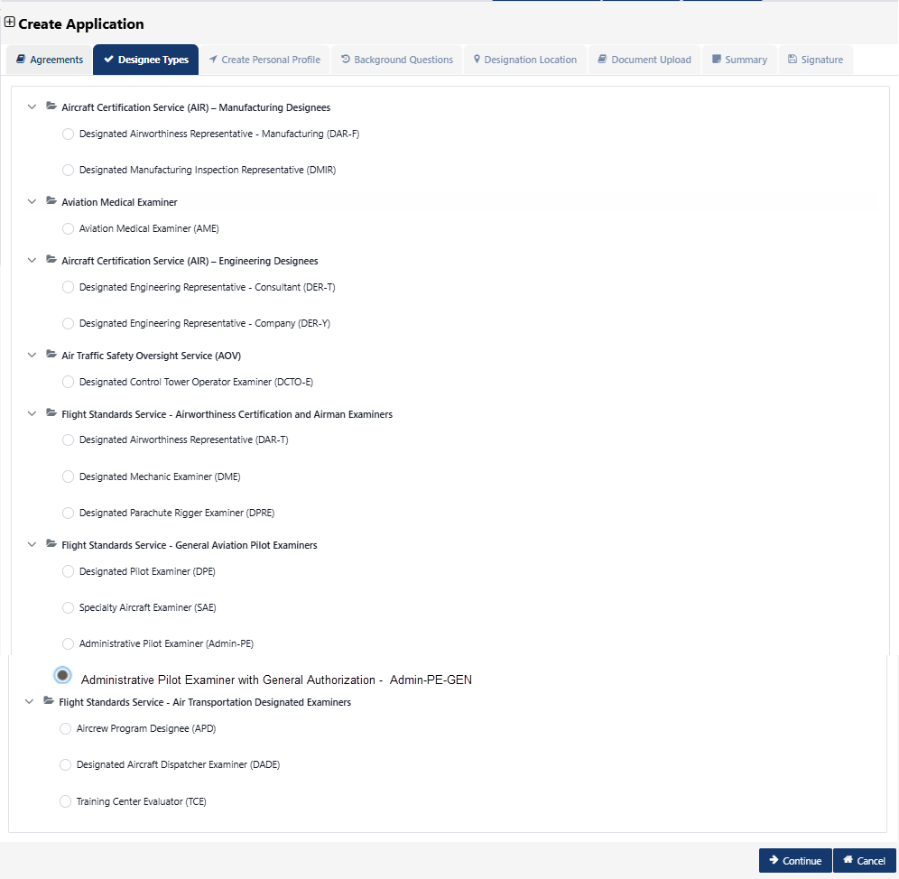
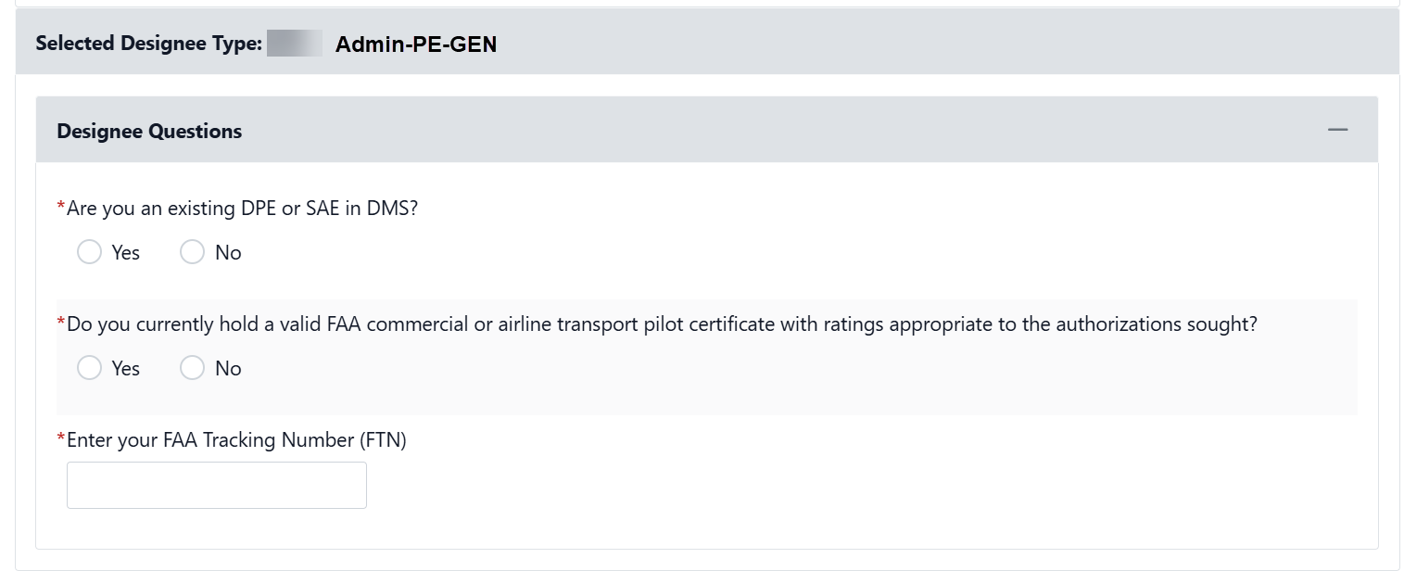
Figure 9: Application - Designee type questions

- Once ADMIN-PE-GEN application type is selected the system shall display Designee Question section:
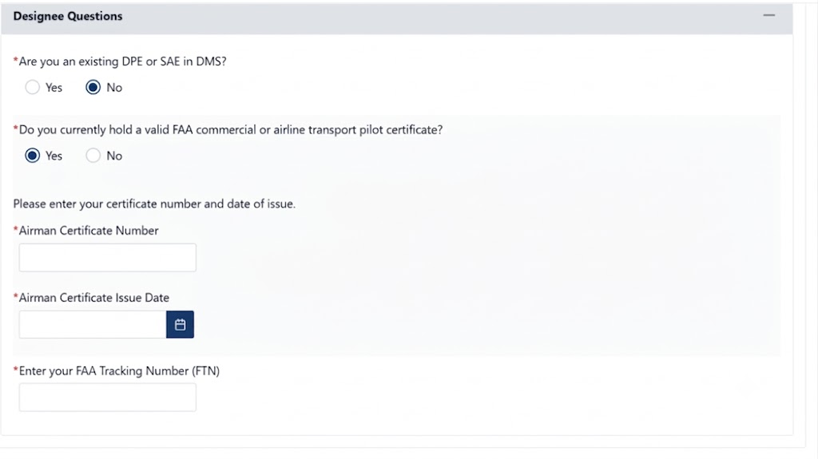
Figure 10: Designee type questions
- The first question is: Are you existing DPE or SAE in DMS
  - Yes, shall stop the application process and display message to exist from application
  - No, shall allow user to continue
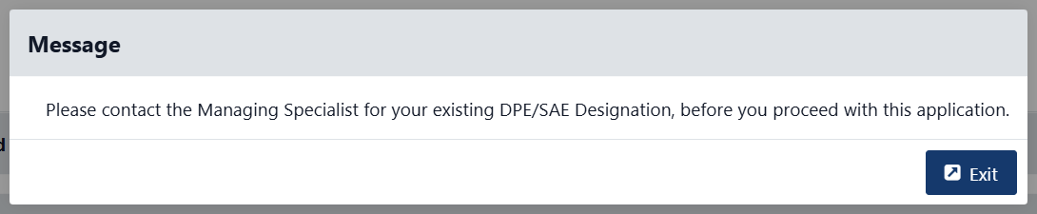
- The second question is: Do you currently hold a valid FAA commercial or airline transport pilot certificate with ratings appropriate to the authorizations sought?
- The second question is: Do you currently hold a valid FAA commercial or airline transport pilot certificate?
Yes, No

  - Yes, shall continue the application and display ‘Please enter your certificate number and date of issue’ section:
    - Airman Certificate Number
    - Airman Certificate Issue Date
  - No, shall stop the apply process and display message to exit from application
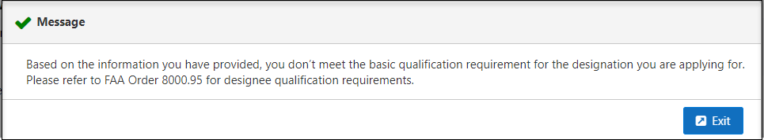
Figure 11: Application - Hard stop message
- The ‘Enter your FAA Tracking Number (FTN) field shall have 8 numeric data
- The save shall save the entry and remail user on the page
- The continue shall save the entry and navigate user to next tab ‘Create Personal Profile’
- The cancel shall display message and confirm before canceling the entry
  - Are you sure you want to cancel?
    - Yes, shall cancel
    - No, shall remain in the page

Table 2: Application Types
Attribute Name | Field Type | Required (Y/N) | Format/Function | Error Message When Required
DAR-F | Radio button | N | Text
DMIR | Radio button | N | Text
AME | Radio button | N | Text
DCT-E | Radio button | N | Text
DER-T | Radio button | N | Text
DER-Y | Radio button | N | Text
DAR-T | Radio button | N | Text
DME | Radio button | N | Text
DPRE | Radio button | N | Text
DPE | Radio button | N | Text
SAE | Radio button | N | Text
Admin-PE | Radio button | N | Text
Admin-PE-Gen | Radio button | N | Text
APD | Radio button | N | Text
DADE | Radio button | N | Text
TCE | Radio button | N | Text

Table 3: Designee Questions
Attribute Name | Field Type | Required (Y/N) | Format/Function | Error Message When Required
Are you an existing DPE or SAE in DMS? | Radio button | Y | - If No, proceed.  If Yes, return home. | This field is required
Do you currently hold a valid FAA commercial or airline transport pilot certificate? | Radio button | Y | - If Yes, display additional fields and questions under this form.  - If No, return to home page  Additional fields if ‘Yes’ is selected:  - Airman Certificate Number  - Airman Certificate Issue Date | This field is required
Enter your FAA Tracking Number (FTN) | Text field | Y | Text Box | This field is required

Create Personal Profile
Personal profile section is filled with users’ information from registration.
User Profile:
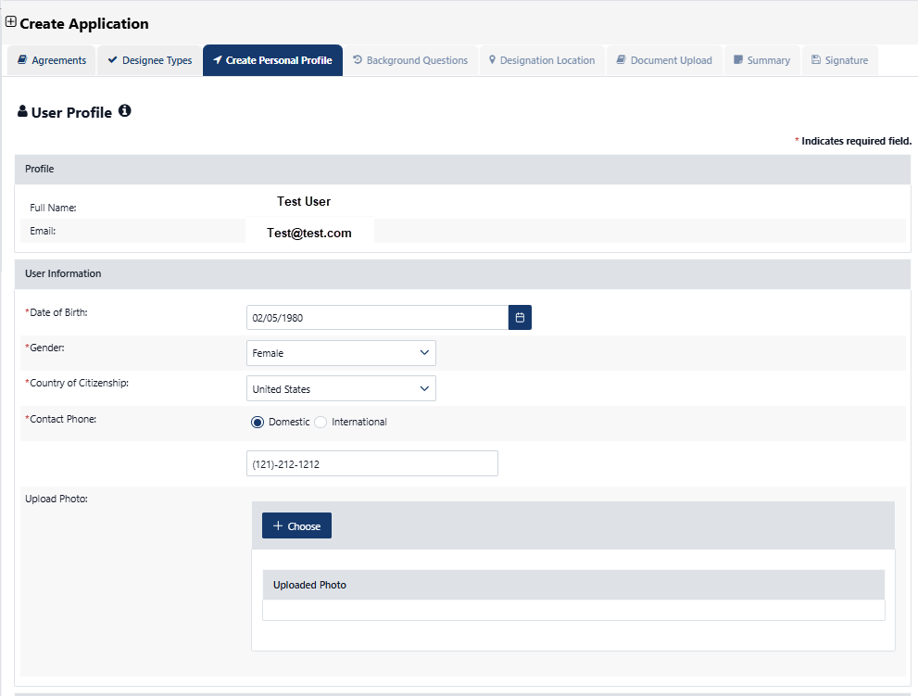
Figure 12: Application – Create Personal Profile
The following under Profile shall be auto populated and cannot be editable:
- Full Name – not editable (data is pulled from Login.gov)
- Email address – not editable (pulled from Login.gov
Following fields shall be displayed under user information shall be required to continue the apply process:
- Date of Birth
  - Date picker displays the calendar years from 1920 to 2040
  - Note: Validate date of birth to ensure the applicant is at least 23 years of age, if not, display the following validation message:
  - Error message for under 23 year selection on the calendar - Based on the information you have provided, you don’t meet the basic eligibility requirements to apply for a FAA designation. Please refer to FAA Order 8000.95 for eligibility and qualification requirements. Please cancel your application.
- Gender
  - Male
  - Female
- Country of Citizenship
- Contact Phone:
  - Domestic radio buttons – Shall allow US phone number
  - International radio buttons
- Upload Photo
  - The system accepts only an image file. If else, the following error massage will display “Practice#1.docx: Invalid file type, allowed file types: image/*”
Address Information:
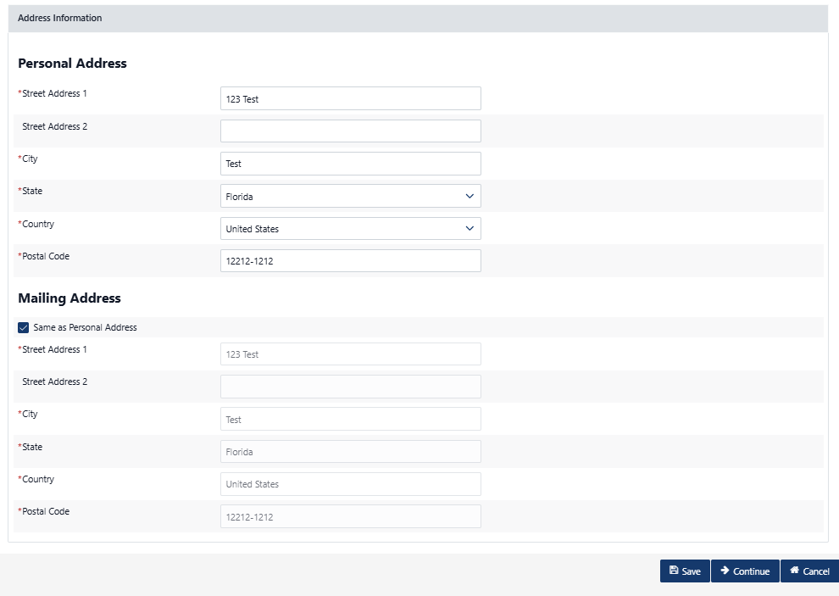
Figure 13: Create Personal Profile - Address
The following fields shall be displayed under Address Information and required to entry to continue the apply.
Personal Address:
- Street Address
- Street Address 2
- City
- State (if country doesn’t equal USA, then this isn’t required)
- Country (default United States)
- Postal Code (if country equals USA, then this is required and only 5 digits are allowed.)
Mailing address
- Same as Personal Address – shall auto populate the personal address
- Street Address 1
- Street Address 2
- City
- State (if country doesn’t equal USA, then this isn’t required)
- Contact Country (default United States)
- Postal Code (if country equals USA, then this is required and only 5 digits are allowed.)
- If Same as Personal Address is selected, System will fill the Mailing Address fields with the Personal Address information.
- If else, the user enters all the required date and selects the following buttons.
- Save: Saves and validates the information entered.
- Continue: Saves and Validates the information and directs the user to Background Questions tab.
- The cancel shall display message and confirm before canceling the entry
  - Are you sure you want to cancel?
    - Yes, shall cancel
    - No, shall remain in the page
- The system shall display Success Message after continuing to next tab
  - Application has been saved successfully!

Table 4: Data Requirements – Create Personal Profile
Attribute Name | Field Type | Required (Y/N) | Format/Function | Error Message When Required
User Profile | Header | N/A
Full Name | Read only text | N/A | Auto populated from user information
Email | Read only text | N/A | Auto populated from user information
Date of Birth | Date | Yes | If the user is less than 23 years old, the system displays validation error message. | Birth Date is required.
Gender | Dropdown | Yes |  | Gender is required.
Country of Citizenship | Dropdown | Yes | The list of countries does not get updated. | Country of citizenship is required.
Contact Phone | Radio buttons and Digit | Yes | If user selects domestic display format is (XXX) XXX-XXXX, International is selected then allow 20 alpha numeric characters | Contact Phone is required.
Upload Photo | File | No
Address Information | Header | N/A
Personal Address | Header | N/A
Street Address | String | Yes |  | Street Address is required.
Street Address 2 | String | No
City | String | Yes |  | City is required.
State | Dropdown | Conditional | Hide if country doesn’t = US | State is required.
Country (default to United States) | Dropdown | Yes |  | Country is required.
Postal Code | String | Conditional | If country equals USA, then this is required and only 9 digits are allowed. International is selected then allow 20 alpha numeric characters
Mailing Address | Header | N/A
Same as Personal Address | Check box | No
Street Address | String | Yes |  | Street Address is required.
Street Address 2 | String | No
City | String | Yes |  | City is required.
State | Dropdown | Conditional | Hide if country doesn’t = US | State is required.
Country (default to United States) | Dropdown | Yes |  | Country is required.
Postal Code | String | Conditional | If country equals USA, then this is required and only 9 digits are allowed. International is selected then allow 20 alpha numeric characters
Save | Button | No | Saves the entry in the system and changes the application status to in-progress
Continue | Button | No | Saves and continue the application process to next tab
Cancel | Button | No | Cancel and exit the application

Background Questions – replace background question image
Background questions are displayed with Yes and No radio buttons. Based on the questions answers application shall be eligible or not eligible

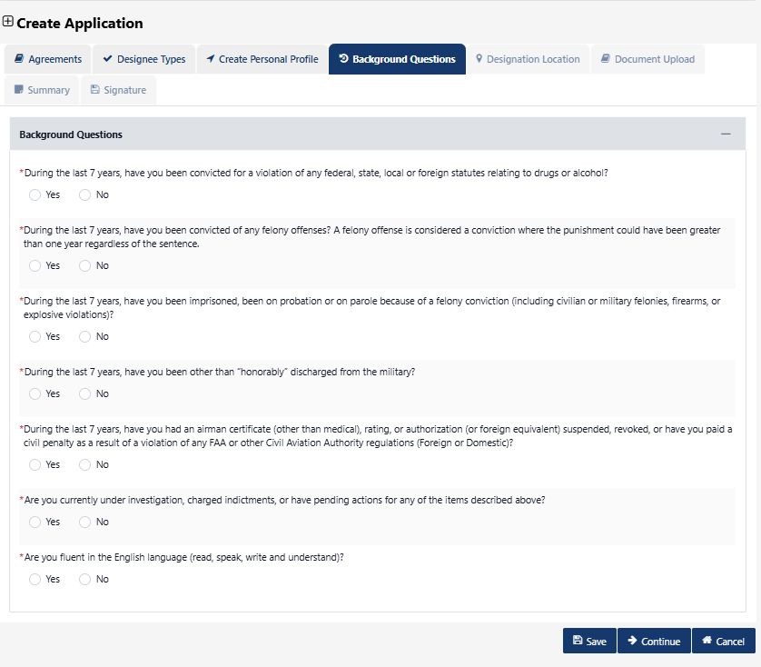
Figure 14: Background Questions

- During the last 7 years, have you been convicted for a violation of any federal, state, local or foreign statutes relating to drugs or alcohol?
  - Yes or No
  - Yes, shall disqualify the application
- During the last 7 years, have you been convicted of any felony offenses? A felony offense is considered a conviction where the punishment could have been greater than one year regardless of the sentence.
  - Yes or No
  - Yes, shall disqualify the application
- During the last 7 years, have you been imprisoned, been on probation or on parole because of a felony conviction (including civilian or military felonies, firearms, or explosive violations)?
  - Yes or No
  - Yes, shall disqualify the application
- During the last 7 years, have you been other than “honorably” discharged from the military?
  - Yes or No
  - Yes, shall disqualify the application
- During the last 7 years, have you had an airman certificate (other than medical), rating, or authorization (or foreign equivalent) suspended, revoked, or have you paid a civil penalty as a result of a violation of any FAA or other Civil Aviation Authority regulations (Foreign or Domestic)?
  - Yes or No
  - Yes, shall disqualify the application
- Are you currently under investigation, charged indictments, or have pending actions for any of the items described above?
  - Yes or No
  - Yes, shall disqualify the application
- Are you fluent in the English language (read, speak, write and understand)?
  - Yes or No
  - No, shall disqualify the application
- User selects the following buttons
  - Save: Saves and validates the information entered.
  - Cancel: Takes the User to the home page.
  - Continue: Saves and Validates the information and directs the user to Designation Location tab.
- Save: Saves and validates the information entered.
- Continue: Saves and Validates the information and directs the user to Designee Locator tab.
- The cancel shall display message and confirm before canceling the entry
  - Are you sure you want to cancel?
    - Yes, shall cancel
    - No, shall remain in the page
- The system shall display Success Message after continuing to next tab
  - Application has been saved successfully!

Table 5: Data Requirement - Background Questions
Attribute Name | Field Type | Required (Y/N) | Format/Function | Error Message When Required
During the last 7 years, have you been convicted for a violation of any federal, state, local or foreign statutes relating to drugs or alcohol? | Boolean | Yes | Values: Yes/No  User must answer No to be qualified. Validation takes place upon submit of application (This is a soft stop). | This field is required.
During the last 7 years, have you been convicted of any felony offenses? A felony offense is considered a conviction where the punishment could have been greater than one year regardless of the sentence. | Boolean | Yes | Values: Yes/No  User must answer No to be qualified. Validation takes place upon submit of application (This is a soft stop). | This field is required
During the last 7 years, have you been imprisoned, been on probation or on parole because of a felony conviction (including civilian or military felonies, firearms, or explosive violations)? | Boolean | Yes | Values: Yes/No  User must answer No to be qualified. Validation takes place upon submit of application (This is a soft stop). | This field is required
During the last 7 years, have you been other than “honorably” discharged from the military? | Boolean | Yes | Values: Yes/No  User must answer No to be qualified. Validation takes place upon submit of application (This is a soft stop). | This field is required
During the last 7 years, have you had an airman certificate (other than medical), rating, or authorization (or foreign equivalent) suspended, revoked, or have you paid a civil penalty as a result of a violation of any FAA or other Civil Aviation Authority regulations (Foreign or Domestic)? | Boolean | Yes | Values: Yes/No  User must answer No to be qualified. Validation takes place upon submit of application (This is a soft stop). | This field is required
Are you currently under investigation, charged indictments, or have pending actions for any of the items described above? | Boolean | Yes | Values: Yes/No  User must answer No to be qualified. Validation takes place upon submit of application (This is a soft stop). | This field is required
Are you fluent in the English language (read, speak, write and understand)? Are you fluent in the English language (read, speak, write and understand)? | Boolean | Yes | Values: Yes/No  User must answer Yes to be qualified. Validation takes place upon submit of application (This is a soft stop). | This field is required
Save | Button | NO | Saves the entry in the system and changes the application status to in-progress
Continue | Button | No | Saves and continue the application process to next tab
Cancel | Button | No | Cancel and exit the application

Designation Location
Designee location information shall be added in the designee CLOA.
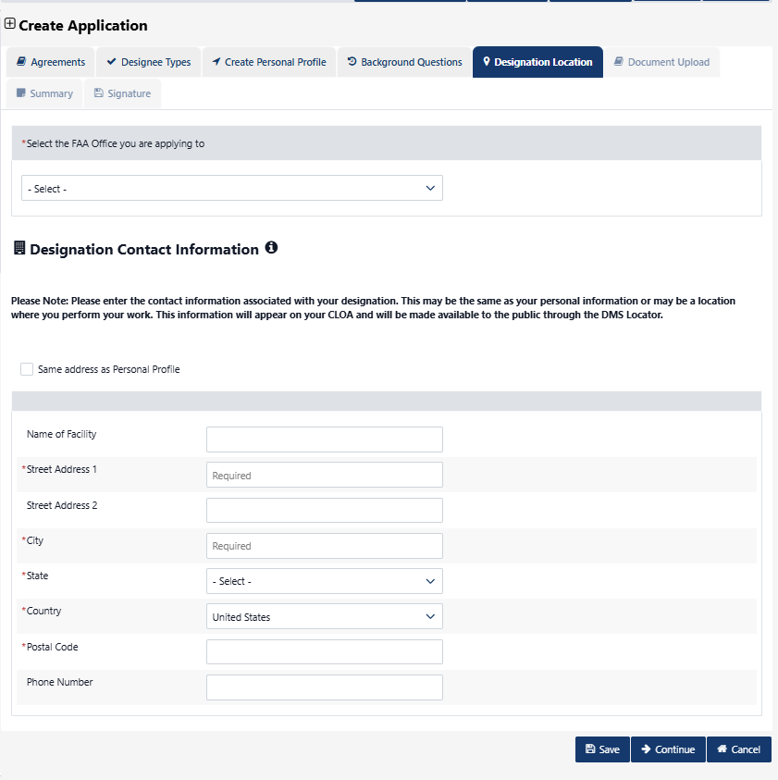
Figure 15: Application – Designee Locator
Designee contact information:
- Select the FAA Office you are applying to
  - The system shall include current AFS offices
- Street Address
- Street Address 2
- City
- State (if country doesn’t equal USA, then this isn’t required)
- Country (default United States)
- Postal Code (if country equals USA, then this is required and only 5 digits are allowed.)
- Phone number
- Save: Saves and validates the information entered.
- Continue: Saves and validates the information and directs the user to Authorization tab.
- The cancel shall display message and confirm before canceling the entry
  - Are you sure you want to cancel?
    - Yes, shall cancel
    - No, shall remain in the page
- The system shall display Success Message after continuing to next tab
  - Application has been saved successfully!
The user shall be able to select Same address as Personal Profile:
- The system shall populate the profile address information
- Save: Saves and validates the information entered
- Continue: Saves and validates the information and directs the user to Authorization tab.
- The cancel shall display message and confirm before canceling the entry
  - Are you sure you want to cancel?
    - Yes, shall cancel
    - No, shall remain in the page
- The system shall display Success Message after continuing to next tab
  - Application has been saved successfully!
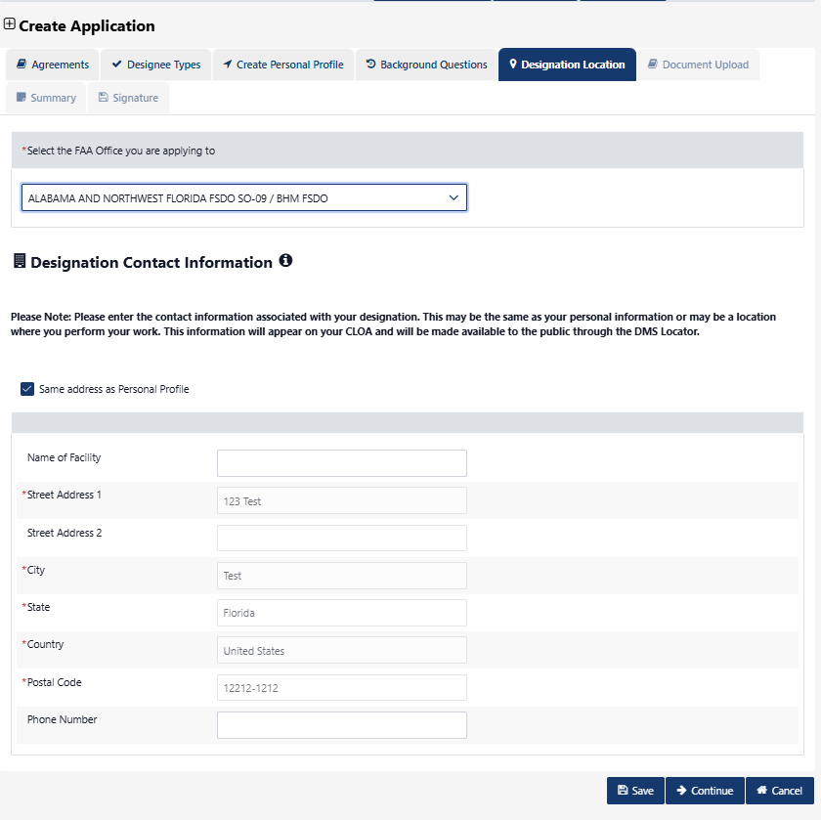
Figure 16: Designee location - Same as personal profile

Table 6: Data Requirements - Designee Locator
Attribute Name | Field Type | Required (Y/N) | Format/Function | Error Message When Required
FAA Office you are applying to | Type ahead Drop- down | Yes | List of AFS Offices | This field is required
Designee Contact Information | Text | N/A
Please enter the contact information associated with your designation. This may be the same as your personal information or may be the location where you perform your work. This information will appear on your CLOA. | Text | N/A
Street Address | String | Yes |  | Street Address is required.
Street Address 2 | String | No
City | String | Yes |  | City is required.
State | Dropdown | Conditional | Hide if country doesn’t = US | State is required.
Country (default to United States) | Dropdown | Yes |  | Country is required.
Postal Code | String | Conditional | If country equals USA, then this is required and only 9 digits are allowed. International is selected then allow 20 alpha numeric characters
Save | Button | NO | Saves the entry in the system and changes the application status to in-progress
Continue | Button | No | Saves and continue the application process to next tab
Cancel | Button | No | Cancel and exit the application

Upload Document
This section shall include Designee related questions and attachments section to upload application related document.
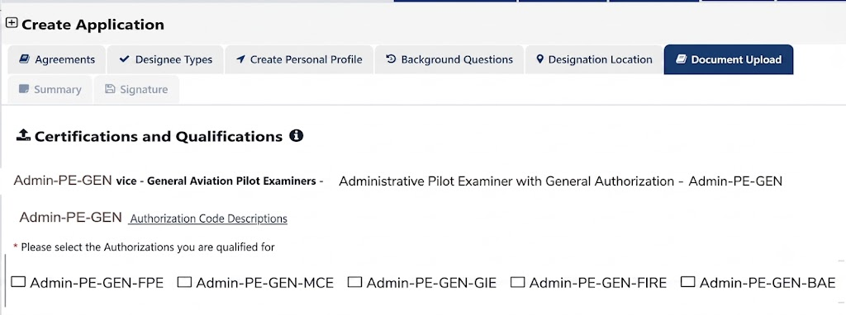
Figure 17: Document upload - Authorization section
Certification and Qualifications section includes:
- Authorization Code Description link – shall include description for each function code for Admin-PE-GEN designee type
- List of Authorizations:
  - Admin-PE-GEN-FPE
  - Admin-PE-GEN-MCE
  - Admin-PE-GEN-GIE
  - Admin-PE-GEN-FIRE
  - Admin-PE-GEN-BAE
- At least one authorization type is required
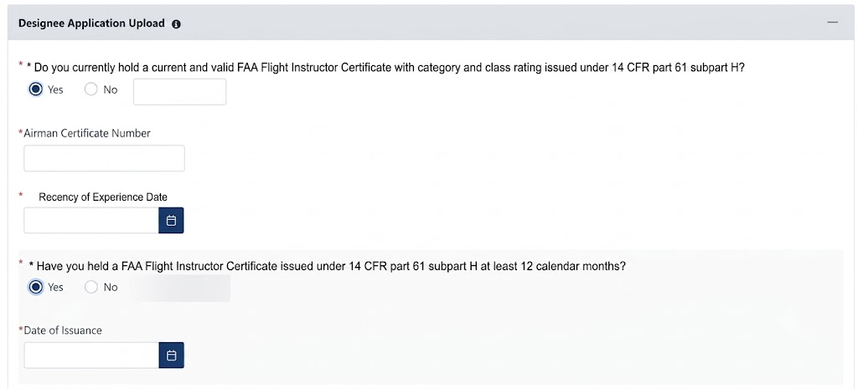
Figure 18: Document Upload - Designee Questions
Designee Application Upload section shall include designee questions:
- Do you currently hold a current and valid FAA Flight Instructor Certificate with category and class rating issued under 14 CFR part 61 subpart H?
  - Yes: shall display:
    - Airman Certification Number
    - Recency of Experience Date
      - Calendar field shall not allow selection in future or more than 24 months in the past
- Have you held a FAA Flight Instructor Certificate issued under 14 CFR part 61 subpart H at least 12 calendar months?
  - Yes
    - Date of Issuance
  - No
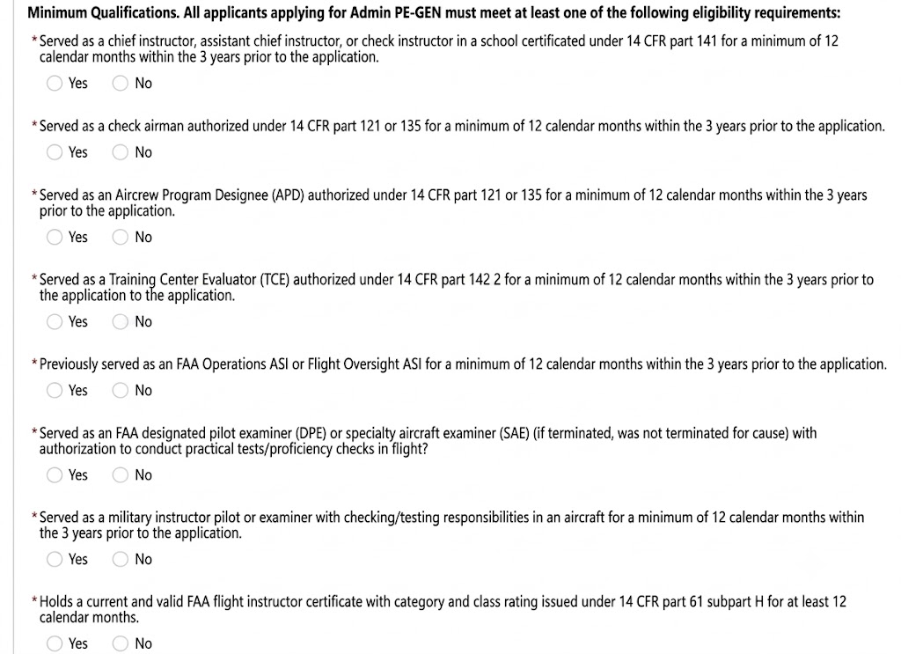
Figure 19: Document Upload - Designee Questions for Three Years Period

Within three years prior to application, have you met at least one of the following? Section includes below questions:
- Served as chief instructor, assistant chief instructor or check instructor for a minimum of 12 calendar-months in a school authorized under 14 CFR part 141?
  - Yes
    - School Name
    - Date from
    - Date to
  - No
Minimum Qualifications. All applicants applying for Admin PE-GEN must meet at
least one of the following eligibility requirements:

- Served as a chief instructor, assistant chief instructor, or check instructor in a school certificated under 14 CFR part 141 for a minimum of 12 calendar months within the 3 years prior to the application. Yes or No
  - A Yes response results in a to/from date entry
    - Start date: (Cannot select a start date greater than 3 years in the past)
    - End date:

- Served as a check airman authorized under 14 CFR part 121 and/or part 135 for a minimum of 12 calendar-months?
  - Yes
    - Air Carrier/Operation Name
    - Date from
    - Date to
  - No
- Served as a check airman authorized under 14 CFR part 121 or 135 for a minimum of 12 calendar months within the 3 years prior to the application. Yes/No
  - A Yes response results in a to/from date entry
    - Start date: (Cannot select a start date greater than 3 years in the past)
    - End date:

- Served as an aircrew program designee (APD) (if terminated, was not terminated for cause) under 14 CFR part 121 for a minimum of 12 calendar-months?
  - Yes
    - Air Carrier/Operation Name
    - Date from
    - Date to
  - No
- Served as an Aircrew Program Designee (APD) authorized under 14 CFR part 121 or 135 for a minimum of 12 calendar months within the 3 years prior to the application. Yes/No
  - A Yes response results in a to/from date entry
    - Start date: (Cannot select a start date greater than 3 years in the past)
    - End date:

- Served as a training center evaluator (TCE) (if terminated, was not terminated for cause) authorized under 14 CFR part 142 for a minimum of 12 calendar-months?
  - Yes
    - Air Agency Name
    - Date From
    - Date To
  - No
- Served as a Training Center Evaluator (TCE) authorized under 14 CFR part 142 for a minimum of 12 calendar months within the 3 years prior to the application.
  - A Yes response results in a to/from date entry
    - Start date: (Cannot select a start date greater than 3 years in the past)
    - End date:

- Served as a FAA Operations Safety Inspector (ASI) for minimum 12 calendar months
  - Yes
    - FAA Office: drop-down with list of offices
    - Date From
    - Date To
  - No
- Previously served as an FAA Operations ASI or Flight Oversight ASI for a minimum of 12 calendar months within the 3 years prior to the application. Yes/No
  - A Yes response results in a to/from date entry
    - Start date: (Cannot select a start date greater than 3 years in the past)
    - End date:

- Previously served as an aviation safety technician (AST) for a minimum of 12 calendar months and completed on-the-job training (OJT) for administrative authorizations covered by Admin PE-GEN, within the 3 years prior to the application. Yes/No
  - A Yes response results in a to/from date entry
    - Start date: (Cannot select a start date greater than 3 years in the past)
    - End date:

- Served as an FAA designated pilot examiner (DPE) or specialty aircraft examiner (SAE) (if terminated, was not terminated for cause) with authorization to conduct practical tests/proficiency checks in flight?
  - Yes
    - Managing FAA Office
    - Date From
    - Date To
  - No

- Held an FAA pilot examiner designation (that was not terminated for cause) with authorization to conduct practical tests for at least 12 calendar months within the 3 years prior to the application. Yes/No
  - A Yes response results in a to/from date entry
    - Start date: (Cannot select a start date greater than 3 years in the past)
    - End date:

- Served as a military instructor pilot or examiner with checking/testing responsibilities in an aircraft, for a minimum of 12 calendar-months?
  - Yes
    - Name of U.S Armed Forces
    - Date from
    - Date to
    - Please refer to FAA Order 8000.95 for required documents that must be uploaded. – text field
  - No
- Served as a military instructor pilot or examiner with checking/testing responsibilities in an aircraft for a minimum of 12 calendar months within the 3 years prior to the application.

- Served as a Flight Instructor that provided at least the following hours of flight instruction to airmen (based on category of aircraft requested) which led to the issuance of a pilot certificate or rating?
  - Yes
    - Number of Hours
    - Date From
    - Date To
  - No

(9) Holds a current and valid FAA flight instructor certificate with category and class rating issued under 14 CFR part 61 subpart H for at least 12 calendar months. Yes/No
(10) Holds a valid FAA ground instructor certificate issued under 14 CFR part 61 subpart I for at least 12 calendar months and meets the recent experience requirements of 14 CFR § 61.217. Yes/No
(11) Current employee of a 14 CFR part 121 or 135 air carrier or 14 CFR part 142 training center and holds a pilot certificate at the commercial level or higher, has completed training on the duties performed by an Admin PE-GEN, and has been determined by an ASI to be competent to perform those duties. Yes/No
(12) Are you a former FAA Designated Pilot Examiner that was terminated not for cause?
Yes
No

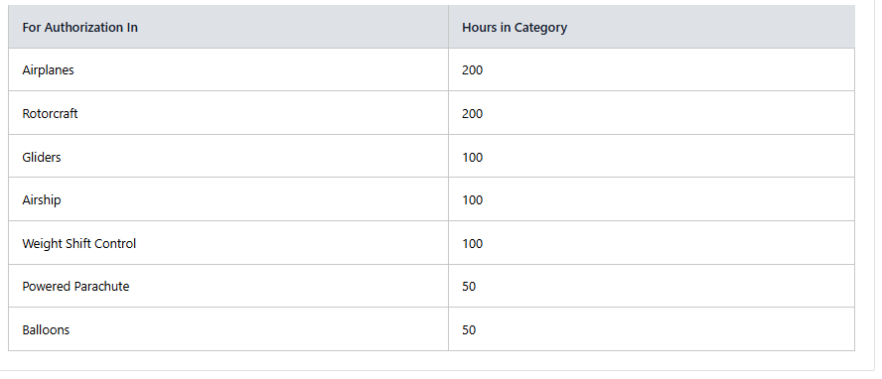
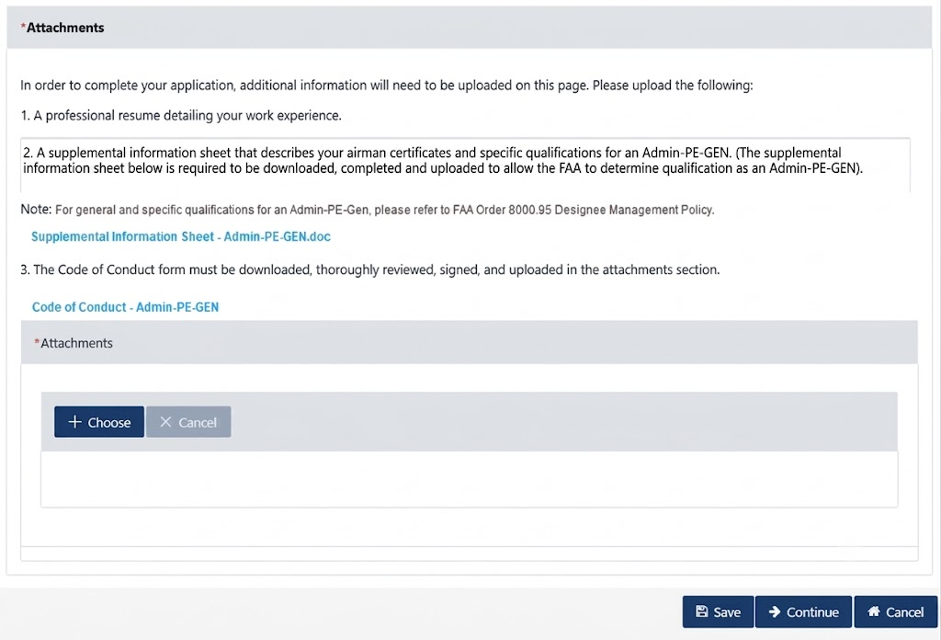
Figure 20: Document Upload - Attachments section

Table 7: Data Requirements – Authorizations
Attribute Name | Field Type | Required (Y/N) | Format/Function | Error Message When Required
Certifications and Qualifications | Header | N/A
Administrative Pilot Examiner with General Authorizations –(Admin-PE-GEN) | Under Header Text – office name | N/A
Admin-PE-GEN Authorization Code Description | Link | N/A | Link to open pop up page with description
o Admin-PE-GEN-FPE  o Admin-PE- GEN-MCE  o Admin-PE- GEN-GIE  o Admin-PE- GEN-FIRE  o Admin-PE- GEN-BAE | Checkbox | Yes |  | Designee Type is required
Designee Application Upload | Header | N/A
1. Do you currently hold a current and valid FAA Flight Instructor Certificate with category and class rating issued under 14 CFR part 61 subpart H? | Boolean | Yes | Values: Yes/No  Yes – opens additional section | This field is required
Airman Certification Number | Text | Yes | Conditional field | This field is required
Recency of Experience Date | Date | Yes | Conditional field  Calendar field shall not allow selection in future or more than 24 months in the past | This field is required
2. Have you held a FAA Flight Instructor Certificate issued under 14 CFR part 61 subpart H at least 24 calendar months?  2. Have you held a FAA Flight Instructor Certificate issued under 14 CFR part 61 subpart H for at least 12 calendar months? | Boolean | Yes | Values: Yes/No  Validation takes place upon submit of application (This is a soft stop). | This field is required
Date of Issuance | Date | Yes | Conditional | This field is required
Within three years prior to application, have you met at least one of the following? | Header | N/A
Served as chief instructor, assistant chief instructor or check instructor for a minimum of 12 calendar-months in a school authorized under 14 CFR part 141?  Served as a chief instructor, assistant chief instructor, or check instructor in a school certificated under 14 CFR part 141 for a minimum of 12 calendar months within the 3 years prior to the application. | Boolean | Yes | Values: Yes/No  . Validation takes place upon submit of application | This field is required
School Name | Text | Yes | Conditional Field | This field is required
Date From | Date | Yes | Conditional Field | This field is required
To | Date | Yes | Conditional Field | This field is required
Served as a check airman authorized under 14 CFR part 121 and/or part 135 for a minimum of 12 calendar-months?  Served as a check airman authorized under 14 CFR part 121 or 135 for a minimum of 12 calendar months within the 3 years prior to the application. | Boolean | Yes | Values: Yes/No  . Validation takes place upon submit of application | This field is required
Air Carrier/Operator Name | Text | Yes | Conditional Field | This field is required
Date From | Date | Yes | Conditional Field | This field is required
To | Date | Yes | Conditional Field | This field is required
Served as an aircrew program designee (APD) (if terminated, was not terminated for cause) under 14 CFR part 121 for a minimum of 12 calendar-months?  Served as an Aircrew Program Designee (APD) authorized under 14 CFR part 121 or 135 for a minimum of 12 calendar months within the 3 years prior to the application. | Boolean | Yes | Values: Yes/No  . Validation takes place upon submit of application | This field is required
Air Carrier/Operator Name | Text | Yes | Conditional Field | This field is required
Date From | Date | Yes | Conditional Field | This field is required
To | Date | Yes | Conditional Field | This field is required
Served as a training center evaluator (TCE) (if terminated, was not terminated for cause) authorized under 14 CFR part 142 for a minimum of 12 calendar-months?  Served as a Training Center Evaluator (TCE) authorized under 14 CFR part 142 for a minimum of 12 calendar months within the 3 years prior to the application. | Boolean | Yes | Values: Yes/No  . Validation takes place upon submit of application | This field is required
Air Agency Name | Text | Yes | Conditional Field | This field is required
Date From | Date | Yes | Conditional Field | This field is required
To | Date | Yes | Conditional Field | This field is required
Served as a FAA Operations Safety Inspector (ASI) for minimum 12 calendar months  Previously served as an FAA Operations ASI or Flight Oversight ASI for a minimum of 12 calendar months within the 3 years prior to the application. | Boolean | Yes | Values: Yes/No  . Validation takes place upon submit of application | This field is required
FAA Office | Drop-down | Yes | Conditional Field  Include list of FAA Offices | This field is required
Date From | Date | Yes | Conditional Field | This field is required
To | Date | Yes | Conditional Field | This field is required
Previously served as an aviation safety technician (AST) for a minimum of 12 calendar months and completed on-the-job training (OJT) for administrative authorizations covered by Admin PE-GEN, within the 3 years prior to the application. | Boolean | Yes | Values: Yes/No  . Validation takes place upon submit of application | This field is required
Start Date | Date | Yes | Conditional Field. Cannot select a start date greater than 3 years in the past. | This field is required
End Date | Date | Yes | Conditional Field. | This field is required
Served as an FAA designated pilot examiner (DPE) or specialty aircraft examiner (SAE) (if terminated, was not terminated for cause) with authorization to conduct practical tests/proficiency checks in flight?  Held an FAA pilot examiner designation (that was not terminated for cause) with authorization to conduct practical tests for at least 12 calendar months within the 3 years prior to the application. | Boolean | Yes | Values: Yes/No  . Validation takes place upon submit of application | This field is required
Managing FAA Office | Drop-down | Yes | Conditional Field  Include list of FAA Offices | This field is required
Date From | Date | Yes | Conditional Field | This field is required
To | Date | Yes | Conditional Field | This field is required
Served as a military instructor pilot or examiner with checking/testing responsibilities in an aircraft, for a minimum of 12 calendar-months?  Served as a military instructor pilot or examiner with checking/testing responsibilities in an aircraft for a minimum of 12 calendar months within the 3 years prior to the application. | Boolean | Yes | Values: Yes/No  . Validation takes place upon submit of application | This field is required
Name of U.S Armed Force | Text | Yes | Conditional Field | This field is required
Date From | Date | Yes | Conditional Field | This field is required
To | Date | Yes | Conditional Field | This field is required
Served as a Flight Instructor that provided at least the following hours of flight instruction to airmen (based on category of aircraft requested) which led to the issuance of a pilot certificate or rating?  Holds a current and valid FAA flight instructor certificate with category and class rating issued under 14 CFR part 61 subpart H for at least 12 calendar months. | Boolean | Yes | Values: Yes/No  . Validation takes place upon submit of application | This field is required
Number of hours | Text | Yes | Conditional Field | This field is required
Date From | Date | Yes | Conditional Field | This field is required
To | Date | Yes | Conditional Field | This field is required
Holds a valid FAA ground instructor certificate issued under 14 CFR part 61 subpart I for at least 12 calendar months and meets the recent experience requirements of 14 CFR § 61.217. | Boolean | Yes | Values: Yes/No. Validation takes place upon submit of application. | This field is required
Current employee of a 14 CFR part 121 or 135 air carrier or 14 CFR part 142 training center and holds a pilot certificate at the commercial level or higher, has completed training on the duties performed by an Admin PE-GEN, and has been determined by an ASI to be competent to perform those duties. | Boolean | Yes | Values: Yes/No. Validation takes place upon submit of application. | This field is required
Table of Hours | Table | N/A | For Authorization In – Hours in Category:  Airplanes - 200  Rotorcraft - 200  Gliders - 100  Airship - 100  Weight Shift Control - 100  Powered Parachute – 50  Balloons - 50
Attachments | Header | N/A
In order to complete your application, additional information will need to be uploaded on this page. Please upload the following:  1. A professional resume detailing your work experience.  2. A supplemental information sheet that describes your airman certificates and specific qualifications for an Admin-PE-GEN. (The supplemental information is required to allow the FAA to determine qualification as an Admin-PE-GEN and determine what authorizations you may qualify for. A sample supplemental information sheet is available for your use, or you may upload the information in a similar format). (The supplemental information sheet below is required to be downloaded, completed and uploaded to allow the FAA to determine qualification as an Admin-PE-GEN).  Note: For general and specific qualifications for a Admin-PE-GEN, please refer to FAA Order 8000.95 Designee Management Policy.  Supplemental Information Sheet – Admin-PE-GEN.doc  3. The Code of Conduct form must be downloaded, thoroughly reviewed, signed, and uploaded in the attachments section.  Code of Conduct – Admin-PE-GEN  4. Include Attachments: Supplemental Information Sheet and Code of Conduct. | Text | N/A
Attachments | Header | N/A
Choose | Button | Yes | To choose the file to upload | Please upload at least one document.
Cancel | Button | No | To cancel the selected file
Save | Button | NO | Saves the entry in the system and changes the application status to in-progress
Continue | Button | No | Saves and continue the application process to next tab
Cancel | Button | No | Cancel and exit the application

Summary
Summary of the application for review before submission. All the fields shall be collected in one page as read only.
- Continue: Saves and Validates the information and directs the user to Signature tab
- The cancel shall take the user to homepage

Signature
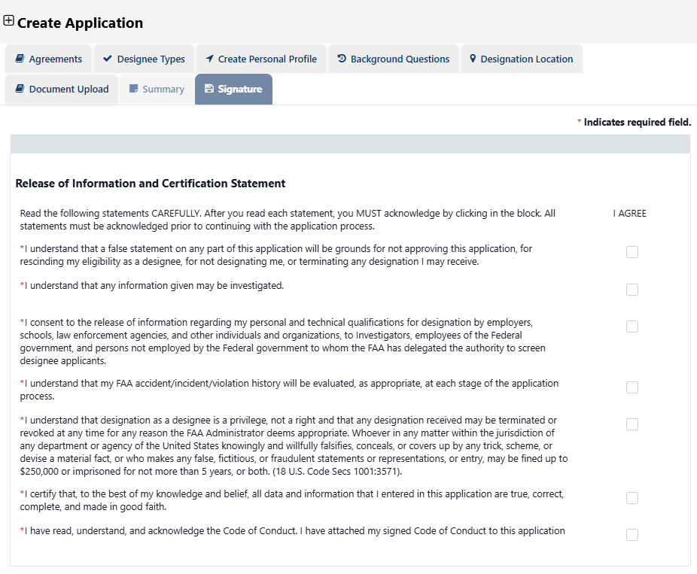
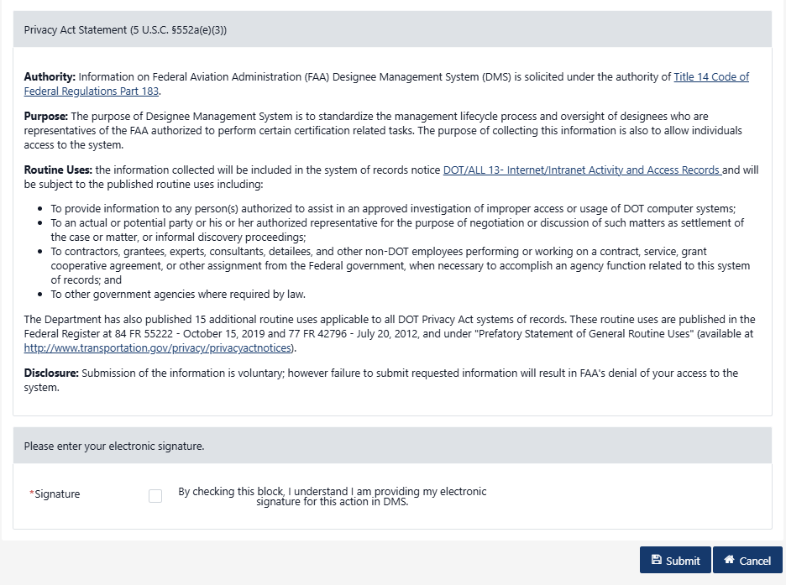
Figure 21: Application Signature

Signature tab shall display Release of Information and Certification Statement sections. User shall check to agree each statement and sign to submit the application. Below statements have each I agree check box and required.
Read the following statements CAREFULLY. After you read each statement, you MUST acknowledge by clicking in the block. All statements must be acknowledged prior to continuing with the application process.
- I understand that a false statement on any part of this application will be grounds for not approving this application, for rescinding my eligibility as a designee, for not designating me, or terminating any designation I may receive.
- I understand that any information given may be investigated.
- I consent to the release of information regarding my personal and technical qualifications for designation by employers, schools, law enforcement agencies, and other individuals and organizations, to Investigators, employees of the Federal government, and persons not employed by the Federal government to whom the FAA has delegated the authority to screen designee applicants.
- I understand that my FAA accident/incident/violation history will be evaluated, as appropriate, at each stage of the application process.
- I understand that designation as a designee is a privilege, not a right and that any designation received may be terminated or revoked at any time for any reason the FAA Administrator deems appropriate. Whoever in any matter within the jurisdiction of any department or agency of the United States knowingly and willfully falsifies, conceals, or covers up by any trick, scheme, or devise a material fact, or who makes any false, fictitious, or fraudulent statements or representations, or entry, may be fined up to $250,000 or imprisoned for not more than 5 years, or both. (18 U.S. Code Secs 1001:3571).
- I certify that, to the best of my knowledge and belief, all data and information that I entered in this application are true, correct, complete, and made in good faith.
- Privacy Act Statement (5 U.S.C. §552a(e)(3)) – displays the text.
- The user shall select the check box as a signature.
- Cancel – takes the user back to homepage
- Submit – submits the application display pop up message:
  - If the application is eligible, user should see a pop-up, “Success: Thank you for your interest in becoming a designated representative of the Federal Aviation Administration (FAA). Based on the information you provided, you have met the basic eligibility requirements to be appointed as a designee. Prior to appointment, the responsible FAA office will evaluate your designee specific qualifications and other information submitted in your application to determine if you meet all qualification requirements. Eligibility does not guarantee appointment as a designee. Appointment is made solely at the discretion of the FAA when there is a need for and the ability to manage additional designees. Please refer to the message in your message center for additional information on your application.”
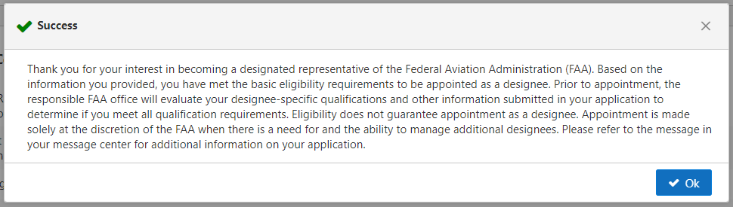
Figure 22: Eligible Application Message
  - If the application is ineligible, user should see a pop-up, “Your designee application has been successfully submitted in DMS, however, based on the information you have provided, you don’t meet the basic eligibility or qualification requirements for the designation you are applying for. Please refer to FAA Order 8000.95 for designee qualification requirements. If you determine that you possess the eligibility and qualification requirements, you may resubmit your application. Please review your answers in your application and ensure your responses to the questions are correct.
Thank you for participating in the designee application process”.
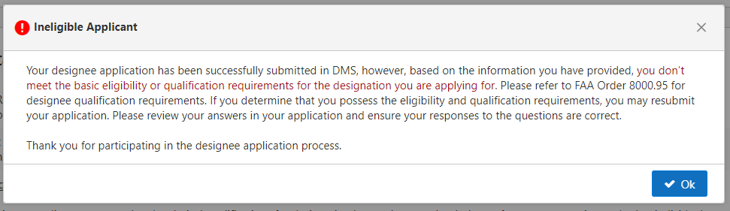
Figure 23: Not Eligible Application Message
  - The user shall be able to close the pop up message with OK button or x on the page

Table 8: Data Requirements - Signature
Attribute Name | Field Type | Required (Y/N) | Format/Function | Error Message When Required
Release of Information and Certification Statement | Header | N/A
Read the following statements CAREFULLY. After you read each statement, you MUST acknowledge by clicking in the block. All statements must be acknowledged prior to continuing with the application process. | Under Header Text | N/A
I understand that a false statement on any part of this application will be grounds for not approving this application, for rescinding my eligibility as a designee, for not designating me, or terminating any designation I may receive. | Check box | Yes |  | This field is required
I understand that any information given may be investigated | Check box | Yes |  | This field is required
I consent to the release of information regarding my personal and technical qualifications for designation by employers, schools, law enforcement agencies, and other individuals and organizations, to Investigators, employees of the Federal government, and persons not employed by the Federal government to whom the FAA has delegated the authority to screen designee applicants. | Checkbox | Yes |  | This field is required
I understand that my FAA accident/incident/violation history will be evaluated, as appropriate, at each stage of the application process. | Checkbox | Yes |  | This field is required
I understand that designation as a designee is a privilege, not a right and that any designation received may be terminated or revoked at any time for any reason the FAA Administrator deems appropriate. Whoever in any matter within the jurisdiction of any department or agency of the United States knowingly and willfully falsifies, conceals, or covers up by any trick, scheme, or devise a material fact, or who makes any false, fictitious, or fraudulent statements or representations, or entry, may be fined up to $250,000 or imprisoned for not more than 5 years, or both. (18 U.S. Code Secs 1001:3571). | Checkbox | Yes |  | This field is required
I certify that, to the best of my knowledge and belief, all data and information that I entered in this application are true, correct, complete, and made in good faith. |  |  |  | This field is required
Privacy Act Statement (5 U.S.C. §552a(e)(3)) | Header | N/A
Authority: Information on Federal Aviation Administration (FAA) Designee Management System (DMS) is solicited under the authority of Title 14 Code of Federal Regulations Part 183.  Purpose: The purpose of Designee Management System is to standardize the management lifecycle process and oversight of designees who are representatives of the FAA authorized to perform certain certification related tasks. The purpose of collecting this information is also to allow individuals access to the system.  Routine Uses: the information collected will be included in the system of records notice DOT/ALL 13- Internet/Intranet Activity and Access Records and will be subject to the published routine uses including:  To provide information to any person(s) authorized to assist in an approved investigation of improper access or usage of DOT computer systems;  To an actual or potential party or his or her authorized representative for the purpose of negotiation or discussion of such matters as settlement of the case or matter, or informal discovery proceedings;  To contractors, grantees, experts, consultants, detailees, and other non-DOT employees performing or working on a contract, service, grant cooperative agreement, or other assignment from the Federal government, when necessary to accomplish an agency function related to this system of records; and  To other government agencies where required by law.  The Department has also published 15 additional routine uses applicable to all DOT Privacy Act systems of records. These routine uses are published in the Federal Register at 84 FR 55222 - October 15, 2019 and 77 FR 42796 - July 20, 2012, and under "Prefatory Statement of General Routine Uses" (available at http://www.transportation.gov/privacy/privacyactnotices).  Disclosure: Submission of the information is voluntary; however failure to submit requested information will result in FAA's denial of your access to the system. | Static Text | N/A
Please enter your electronic signature. | Header
Signature  By checking this block, I understand I am providing my electronic signature for this action in DMS. | Checkbox | Yes |  | This field is required
Submit | Button |  | Submits the application
Cancel | Button | No | Cancel and exit the application

Message center
Applicant shall receive message in DMS message center and in email associated with account. The email shall be triggered when application is submitted.
- Eligible application:
  - Title: Admin-PE-GEN Application Submitted Successfully--Basic Eligibility Requirements have been Met
  - Date and time
  - From: System Administrator
  - To: Applicant’s name
  - Body:
<applicant name>,
Your designee application has been successfully submitted in DMS.

Thank you for your interest in becoming a designated representative of the Federal Aviation Administration (FAA). Based on the information you provided, you have met the basic eligibility requirements to be appointed as a designee. Prior to appointment, the responsible FAA office will evaluate your specific qualifications and other information submitted in your application to determine if you meet all the qualification requirements. Eligibility does not guarantee you will be appointed as a designee. Appointment is made solely at the discretion of the FAA when there is a need for and the ability to manage additional designees. To remain in consideration, you must continue to meet the basic eligibility requirements for the designation for which you applied.

Your application will remain active in the database of eligible applicants for one year. If you have not been appointed within a year of the date you submitted your application, you must revalidate the information in your application if you wish to continue to be eligible. Please keep your system contact information current so that we may contact you if we determine a need for your services as a designee.
Thank you for applying to be a designee.
Designee Management System (DMS) Administration

- Eligible application:
  - Title: Admin-PE-GEN Application Submitted Successfully--Basic Eligibility Requirements have Not been Met
  - Date and time
  - From: System Administrator
  - To: Applicant’s name
  - Body:
<applicant name>,
Your designee application has been successfully submitted in DMS.
Thank you for your interest in becoming a designated representative of the Federal Aviation Administration (FAA). Based on the information you provided, you have not met the basic eligibility requirements to be appointed as a designee.
Thank you for applying to be a designee.
Designee Management System (DMS) Administration

Application Status
DMS home page displays the application with status and assigned ID.

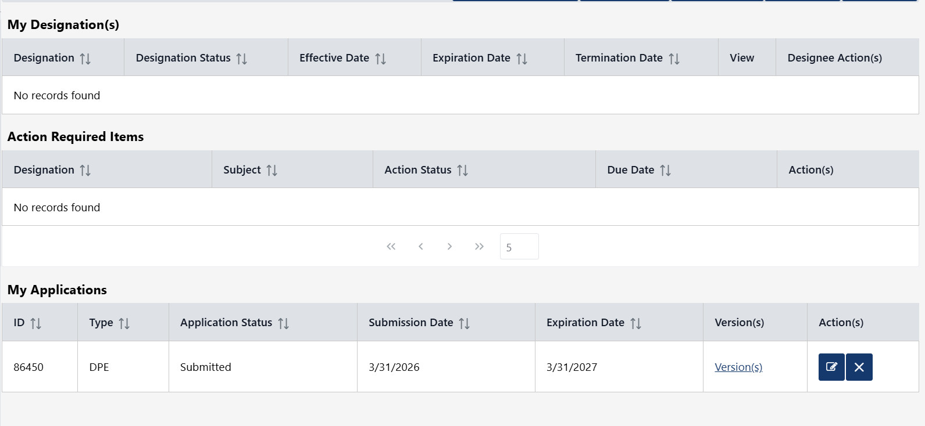
Figure 24: DMS Homepage - Submitted application

- The user shall be able to views the submission information in the home page under My Application section.
  - ID#
  - Type
  - Application Status
    - In progress – when application is in draft status
    - Submitted
  - Submission Date
  - Expiration Date
  - Versions
- Applications can be edited in the following conditions:
  - 1 It’s in “submitted” status
  - It’s in “in progress” status
  - When the user is terminated not for cause or voluntary surrenders
  - When the application expires
- The system shall add new version for each submitted application version
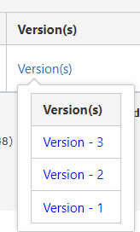
Figure 25: Application Versions
- The application shall expire after one year from submitted date
- The application in in-progress status shall be deleted after 180 days without any activity
- Applications cannot be edited in the following conditions
  - When the designee has been selected in the selection search
  - When the designee has been terminated for cause
- User shall be able to cancel the application before selection begins
  - Once user cancel the application, the system shall send message to the user’s message center
  - User shall be able to create and resubmit the application again

Appendices

Appendix A: Glossary
Table 9: Glossary
Term | Definition
External User | Private individuals or general public users of DMS.
Designee | Persons approved to provide certification duties and other services on behalf of the FAA.

Appendix B: Abbreviations, Acronyms, and Definitions

Table 10: Abbreviations, Acronyms, and Definitions
Abbreviation/  Acronym | Definition
FAA | Federal Aviation Administration
DMS | Designee Management System
AIR | Aircraft Certification Service
DMIR | Designated Manufacturing Inspection Representative
DAR-F | Designated Airworthiness Representative-Manufacturing
DCTO-E
AME | Aviation Medical Examiner
DAR-T | Designated Airworthiness Representative
DER- Y | Designated Engineer Representative Company
DER-T | Designated Engineer Representative Consultant
DCTO-E | Designated Control Tower Operator Examiner
DME | Designated Mechanic Examiner
DPRE | Designated Parachute Rigger Examiner
DPE | Designated Pilot Examiner
SAE | Specialty Aircraft Examiner
Admin-PE | Administrative Pilot Examiner
Admin-PE-GEN | Administrative Pilot Examiner with General Authorizations
APD | Aircrew Program Designee
DADE | Designated Aircraft Dispatcher Examiner
TCE | Training Center Evaluator

Appendix C: Country List:
Afghanistan
Albania
Algeria
Andorra
Angola
Antigua and Barbuda
Argentina
Armenia
Australia
Austria
Azerbaijan
Bahamas
Bahrain
Bangladesh
Barbados
Belarus
Belgium
Belize
Benin
Bhutan
Bolivia
Bosnia and Herzevina
Botswana
Brazil
Brunei Darussalam
Bulgaria
Burkina Faso
Burundi
Cambodia
Cameroon
Canada
Cape Verde
Central African Republic
Chad
Chile
China
Colombia
Comoros
Congo Dr
Cook Islands
Costa Rica
Cote D'ivoire
Croatia
Cuba
Cyprus
Czech Republic
Denmark
Djibouti
Dominica
Dominican Republic
Ecuador
Egypt
El Salvador
Equatorial Guinea
Eritrea
Estonia
Ethiopia
Fiji
Finland
France
Gabon
Gambia
Georgia
Germany
Ghana
Greece
Grenada
Guatemala
Guinea
Guinea-Bissau
Guyana
Haiti
Honduras
Hungary
Iceland
India
Indonesia
Iran
Iraq
Ireland
Israel
Italy
Jamaica
Japan
Jordan
Kazakhstan
Kenya
Kiribati
Korea (North)
Korea (South)
Kuwait
Kyrgyzstan
Laos
Latvia
Lebanon
Lesotho
Liberia
Libya
Lithuania
Luxembourg
Madagascar
Malawi
Malaysia
Maldives
Mali
Malta
Marshall Islands
Mauritania
Mauritius
Mexico
Micronesia
Moldova
Monaco
Mongolia
Montenegro
Morocco
Mozambique
Myanmar
Namibia
Nauru
Nepal
Netherlands
New Zealand
Nicaragua
Niger
Nigeria
Norway
Oman
Pakistan
Palau
Panama
Papua New Guinea
Paraguay
Peru
Philippines
Poland
Portugal
Qatar
Republic of Macedonia
Romania
Russian Federation
Rwanda
Saint Kitts And Nevis
Saint Lucia
Saint Martin
Saint Vincent and the Grenedines
Samoa
San Marino
Sao Tome and Principe
Saudi Arabia
Senegal
Serbia
Seychelles
Sierra Leone
Singapore
Slovakia
Slovenia
Solomon Islands
Somalia
South Africa
South Sudan
Spain
Sri Lanka
Sudan
Suriname
Swaziland
Sweden
Switzerland
Syria
Taiwan
Tajikistan
Tanzania
Thailand
Timor-Leste
Togo
Tonga
Trinidad and Tobago
Tunisia
Turkey
Turkmenistan
Uganda
Ukraine
United Arab Emirates
United Kingdom
United States
Uruguay
Uzbekistan
Vanuatu
Venezuela
Vietnam
Yemen
Zambia
Zimbabwe
Zaire
Western Samoa
West Indies
Wake Island
Trust Terr Pac Isl
Ryukyu Islands
Martinique
Johnston Atoll
French Polynesia
Canal Zone
Burma
British Virgin Is
Macau
Hong Kong
Cayman Islands
British West Indies
Bermuda
Aruba
Saipan
Saint Martin

Appendix D: State List
 | Alaska | AK
 | Alabama | AL
 | Arkansas | AR
 | Arizona | AZ
 | California | CA
 | Colorado | CO
 | Connecticut | CT
 | DC | DC
 | Delaware | DE
 | Florida | FL
 | Georgia | GA
 | Hawaii | HI
 | Iowa | IA
 | Idaho | ID
 | Illinois | IL
 | Indiana | IN
 | Kansas | KS
 | Kentucky | KY
 | Louisiana | LA
 | Massachusetts | MA
 | Maryland | MD
 | Maine | ME
 | Michigan | MI
 | Minnesota | MN
 | Missouri | MO
 | Mississippi | MS
 | Montana | MT
 | North Carolina | NC
 | North Dakota | ND
 | Nebraska | NE
 | New Hampshire | NH
 | New Jersey | NJ
 | New Mexico | NM
 | Nevada | NV
 | New York | NY
 | Ohio | OH
 | Oklahoma | OK
 | Oregon | OR
 | Pennsylvania | PA
 | Rhode Island | RI
 | South Carolina | SC
 | South Dakota | SD
 | Tennessee | TN
 | Texas | TX
 | Utah | UT
 | Virginia | VA
 | Vermont | VT
 | Washington | WA
 | Wisconsin | WI
 | West Virginia | WV
 | Wyoming | WY
 | N/A | N/A
 | Guam | GU
 | American Samoa | AS
 | Marshall Islands | MH
 | North Mariana Islands | MP
 | US Minor Outlying Islands | MU
 | Puerto Rico | PR
 | Virgin Islands | VI
 | AE | AE
 | AP | AP

 | Functional Requirements Document  Authorization Memorandum

FAA INFORMATION TECHNOLOGY (AIT) PROJECT MANAGEMENT CERTIFICATION
By signing below, I acknowledge that I have read, reviewed and approved the contents of this document.

________________ ________________________ _____________________
DMS AIT SIGNATURE DATE
Project Manager

________________ _________________________ _____________________
DMS AIT PM’s SIGNATURE DATE
Branch Manager

